

A Project Report

On,

**“ AGRI CREDIT ”**

**Course Code: PIP 103**

**Course Name: University Project-II**

Batch Details

|  |  |  |
| --- | --- | --- |
| **Sl. No.** | **Roll Number** | **Student Name** |
| 1 | 20191CSE0486 | RAMAN CHETTRI |
| 2 | 20191CSE0478 | RAI VENKATA PRADEEP |
| 3 | 20191CSE0541 | SEVANTH M. |
| 4 | 20191CSE0520 | SAHANA V. |
| 5 | 20191CSE0566 | SHREYAS S. |

Under the guidance of,

Dr. Islabudeen

**Associate Professor - CSE**

**School of Computer Science & Engineering**

**Presidency University, Bengaluru**

**CONTENTS**

**1. Introduction about Project**

**2. Literature Review**

**2.1. Existing Methods – Drawback**

**3. Proposed Method**

**4. Objectives**

**5. Methodology**

**6. Design Procedure**

**6.1. Architecture Diagram**

**7. Experimental Details**

**8. Expected Outcomes**

**9. Project Timeline through a Gantt Chart**

**9.1. Project specificity**

**10. Modules**

**11. References**

**11.1. Web Resources**

**11.2. Journal Papers**

1. INTRODUCTION

The digitalization of agriculture describes integrating cutting-edge digital technology into the farm production system, where agriculture sector plays a vital role in accelerating the economic growth. Thus we can all attest to how Agriculture remains the most important sector of Indian economy. Further to help the farmers and improve in agricultural sector, we strive to facilitate and provide a one stop solution for all of the farming necessities and help the scalability of knowledge through a diversified ecosystem for the chain of local farmers.

In addition, Digitalized farmer applications have enabled greater connectivity and communication between farmers, suppliers, and other stakeholders creating opportunities for collaboration and knowledge sharing. This has led to the development of new business models, such as farm-to-market platforms and e-commerce marketplaces, that are transforming the way agricultural products are marketed and distributed.

Overall, digitalized farmer applications are playing a key role in improving the productivity, profitability, and sustainability of agriculture, and are helping to create a more resilient and inclusive farmer ecosystem. Thus we design and develop a web application

“Agri Credit –A Step Ahead Solution Towards Uplift Of Farmers Community”

2. LITERATURE REVIEW

|  |  |  |  |  |
| --- | --- | --- | --- | --- |
| Sl. No. | Paper Title | Method | Advantages | Limitations |
| 1. | Agricultural Situation in India, GENERAL SURVEY OF AGRICULTURE, March 2022 | Explained the information about the farmer news , Statistical data of prices of agricultural commodities, organic farming and estimate the trends in cost of production and farm profitability of crops. |  |  |
| 2. | Indian Agriculture,  Neelam Patel  from Agro Industry to Agro Ecology, 2022 | Briefly reviews the process of structural transformation in India, its key characteristics, and the role of agriculture in the development process. This section tells us that raising land and labour productivity in agriculture is critical in the process of structural transformation. | Better soil fertility  Preserves biodiversity | Missing willingness to share knowledge and collaborate with other farmers. |
| 3. | Production optimization for sustainable agriculture and efficient contract farming in the Republic of Maldives | This research study is carried out to identify the efficiency of farms in crop production from three different regions of Maldives, which have started the contracting farming in 2021 to improve their sustainability and farm management | Farmer is assured of a market since the company guarantees that it will purchase the produce at a pre-determined fixed price | It can lead to greater insecurity as the farmers become dependent on such companies for their livelihoods. |
| 4. | Utility of agricultural mobile apps among Indian rural farmers, 2020  Author – SIVA RATNA KUMARI NARISETTI | To identify the information needs of Indian rural farmers and to inspect agricultural smartphone apps intended for crop farmers for usability (ease of use) and functionality (content, features, and information needs). To these ends, I conducted three studies: studying global agricultural apps (study 1), evaluating an agricultural app developed for Indian farmers with usability experts in the United States (study 2), and finally inspecting the same app with rural farmers in India (study 3) | Provides information on crop production  Smart Farming | Application looks confusing  Missing ease of use |
| 5. | Agricultural Technologies in India: A Review, NABARD Research and Policy Series No. 5/2022 | The study includes the technologies related to: (i) genetic enhancement, (ii) natural resource management, (iii) farm mechanisation, (iv) conservation agriculture, (v) climate smart agriculture, (vi) biotechnology and genetic modification, (vii) biofortification, (viii) frontier technologies, and (ix) digital technologies. | Use of advanced agricultural technologies such as high-yielding crops | Limited scope only covering certain agricultural technologies in India |

2.1. EXISTING METHODS - DRAWBACK

* **Farmer Portal-** Using machine Learning Approaches
* **Drawback: Application is not updated as per the demand**
* **Kristi Portal:** Web Based Farmer Assistance using different technologies such as HTML5, CSS3, JavaScript, Bootstrap 4.0, java.
* **Drawback: More complex design , not able to understand by the farmers easily**
* **Online Agro Product:** The application is developed using XAmp server MySQL Database, PHP,HTML, JavaScript.
* **Drawback: As XAMP is almost outdated now, we need to enhance the system**
* **Agricultural Information :** through Smartphone using Mobile Application Development.
* **Drawback: Costly is development of application**

3. PROPOSED METHOD

* As most of the applications are on Java based and Mobile based Web technologies, We are trying to enhance the features using Python and Django Framework for easy access and faster processing
* There is a need to develop the web application using Django so we are put forward in our proposed system

4. OBJECTIVES

To develop this system we used HTML5, CSS, Bootstrap, and JavaScript. In addition, the Django framework is used to manage the MySQL database. There are few such web applications that provides information in one platform , Hence are trying to develop the system for the farmers to help them in all ways.

The objectives of the Project are :

• Develop a Dashboard for Login / Sign Up and logout ( Farmers, Buyers )

• Developing the system for Farmers shopping module

• Creating the Aggregators Information Panel for Fertilizers, Machineries , Buy / Sell Crops and Other items

• Buy or lease Fertilizers , Machineries and Pesticides .

• Payment Gateways

• Expert Advise Panel

• Forming the Ecosystem for farmers community

5. METHODOLOGY

**Planning and Designing:** The first step is to plan and design the website. This includes defining the scope of the website, the target audience, and the features and functionalities required. It is also important to create wireframes and prototypes to visualize the layout and design of the website.

**Installation and Setup:** The next step is to install and set up the Django framework. This involves creating a virtual environment, installing Django, and setting up the project directory structure.

**Models and Database:** The third step is to create the models for the website and set up the database. This includes creating models for the various entities such as crops, farmers, and orders, and configuring the database settings in the settings.py file.

**Views and Templates:** The fourth step is to create the views and templates for the website. This includes defining the URL routes and creating the views that handle the requests and responses. It also involves creating the templates that define the structure and layout of the website.

**Authentication and Authorization:** The fifth step is to implement authentication and authorization. This includes creating a user model, defining login and registration views, and implementing role-based access control to restrict access to certain parts of the website.

**Integration of Third-party APIs:** The sixth step is to integrate third-party APIs such as for the market data to provide additional features and functionalities to the website.

**Testing and Deployment:** The final step is to test the website thoroughly and deploy it to a production server. This includes testing the functionality, performance, and security of the website and optimizing it for search engine optimization (SEO).

6. DESIGN PROCEDURE

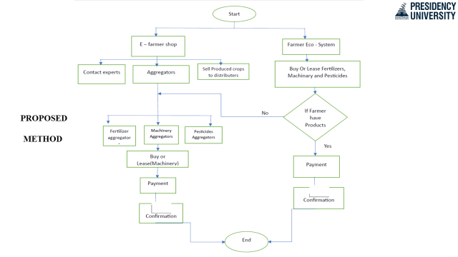

6.1. ARCHITECTURE DIAGRAM

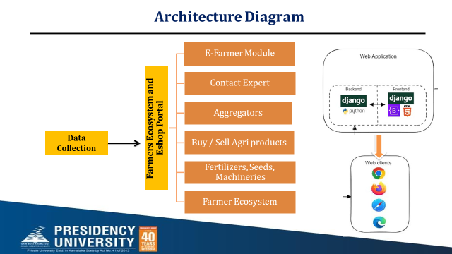

7. EXPERIMENTAL DETAILS

**Software Requirements**

* Scripting language: Python Programming
* Scripting Tool: Visual Studio Code , SQL DB, Python IDLE
* Operating System: Microsoft Windows 8 /10 or 11
* Database: Custom database of Farmers
* Front-End Technologies: HTML, CSS, JAVA SCRIPTS, BOOTSTRAP
* Backend Technologies: SQLITE3 DATABASE
* Web Development Platform: Django using Python Programming

**Hardware Requirements**

* Processor : 3.0 GHz and Above
* Output Devices : Monitor (LCD)
* Input Devices : Keyboard
* Hard Disk : 1 TB
* RAM : 8 GB or Aboce

8. EXPECTED OUTCOMES

**Increased efficiency and productivity:** The use of digital tools and technologies can help farmers and other stakeholders in the agriculture ecosystem to manage their operations more efficiently and effectively, leading to increased productivity and profitability.

**Improved decision-making:** The availability of real-time data and insights through the website can help farmers make more informed decisions about crop management, resource allocation, and marketing strategies.

**Enhanced connectivity and collaboration:** The website can serve as a platform for Farmer-to-Farmer and Farmers-to-Aggregators to connect and collaborate, creating opportunities for knowledge sharing and new business models.

**Increased transparency and trust:** The website can help to increase transparency and trust in the agriculture ecosystem by providing accurate and up-to-date information about crop yields, prices, and other relevant data.

**Improved access to markets:** The e-commerce capabilities of the website can help farmers to reach a broader market and sell their products more easily, improving their access to markets and potentially increasing their profits.

9. TIMELINE OF THE PROJECT/ PROJECT EXECUTION PLAN

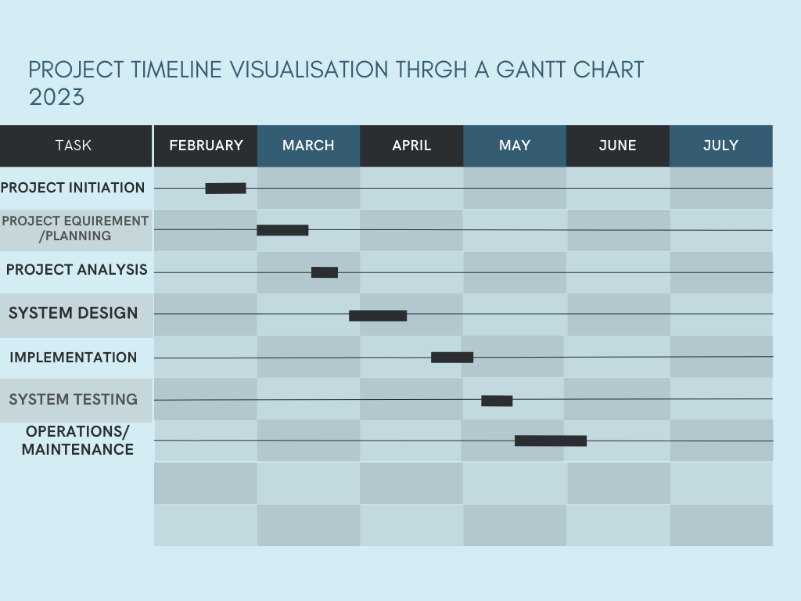

9.1 PROJECT SPECIFICITY STEP-BY-STEP EXPLAINATION

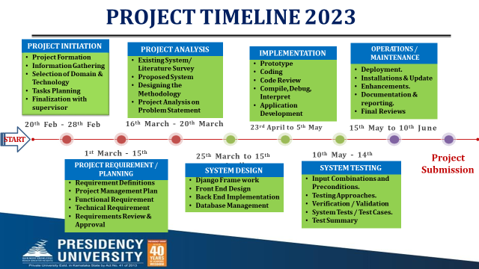

10. MODULES

**Module 1: Dashboard for Login / Sign Up and logout ( Farmers, Buyers )**

**Module 2: Developing the system for Farmers shopping module**

**Module 3: Creating the Aggregators Information Panel for Fertilizers Machineries , Buy / Sell Crops and Other items**

**Module 4: Buy or lease Fertilizers , Machineries and Pesticides**

**Module 5: Payment Gateways**

**Module 6: Expert Advise Panel**

**Module 7: Forming the Ecosystem for farmers community**

11. REFERENCES

11. 1. Web Resources :

1. Farmer’s Portal - <https://farmer.gov.in/>
2. **F**armer **R**egistration and **U**nified beneficiary **Information S**ystem **FRUITS:** https://fruits.karnataka.gov.in/
3. The Farmers' Portal of the Department of Agriculture, Co-operation and Farmers' Welfare: https://[www.india.gov.in/farmers-portal](http://www.india.gov.in/farmers-portal)

11.2. Journal Papers :

1. Finger, R.; Swinton, S.M.; El Benni, N.;Walter, A. Precision Farming at the Nexus of Agricultural

Production and the Environment.Annu. Rev. Resour. Econ. **2019**, 11, 313–335.

1. Mushi, G.E.; Serugendo, G.D.M.; Burgi, P.Y. Digital Technology and Services for Sustainable Agriculture in Tanzania: A Literature Review. Sustainability **2022**, 14, 2415.
2. Reportlinker. The Smart AgricultureMarket. 2020. Available online: https:/[/ww](http://www.reportlinker.com/p05983713/Smart-Agriculture-Market-by-Type-and-)w[.reportlinker.com/p05983713/Smart-Agriculture-Market-by-Type-and-](http://www.reportlinker.com/p05983713/Smart-Agriculture-Market-by-Type-and-)  Component-Global-Opportunity-Analysis-and-Industry-Forecast-.html (accessed on **9 April 2022**).
3. Shri Lalsanglur ; Dr. Promodita Sathish ; Dr. P. Babu, Agricultural situation in India VOL. LXXVIII on **March, 2022** No:12 [**https://eands.dacnet.nic.in**](https://eands.dacnet.nic.in)
4. Neelam Patel ; Bruno Dorin ; Ranveer Nagaich A new paradigm for Indian Agriculture from Agroindustry to Agroecology , NITI Aayog **2022**  [**https://www.niti.gov.in**](https://www.niti.gov.in)
5. IFOAM Organics Europe ; Rue du Commerce ; Brussels - Belgium, **Email:** [**info@organicseurope.bio**](mailto:info@organicseurope.bio)

Organic Agriculture and it’s benefits for climate and biodiversity, LIFE programme **April 2022** [**https://www.organicseurope.bio**](https://www.organicseurope.bio)

1. Nadhiya Abdulla ; Natalia Vasylieva ; Iryna Volovyk, Production optimization for sustainable agriculture and efficient contract farming

Received: **June, 15, 2022**, Accepted: **June, 28, 2022**, Published: **August, 2022**

Bulgarian Journal of Agricultural Science, 28 (No 4) **2022**, 579–590

[**https://www.agrojournal.org/28/04-03.pdf**](https://www.agrojournal.org/28/04-03.pdf)

1. Narisetti ; Siva Ratna Kumari, Utility of agricultural mobile apps among Indian rural farmers, **2020-09-08** (Date deposited **2020-12**)

**https://www.ideals.illinois.edu/items/117174**

GITHUB LINK TO VIEW PPT OF REVIEW-01: **https://github.com/sevanthM/AGRI-CREDIT-**

Signature of Students Signature of Supervisor

|  |  |
| --- | --- |
| Roll Number | Signature |
| 20191CSE0486 |  |
| 20191CSE0478 |  |
| 20191CSE0541 |  |
| 20191CSE0520 |  |
| 20191CSE0566 |  |